**JavaFX Todo List Application - Project Report** **Team Information**

Name: Samiullah Arman

Student ID: 24040102002

GitHub Repository: [https://github.com/Samiullah98/todo.git]

# Project Overview

This JavaFX-based Todo List application offers users a modern interface for task management. Key features include user authentication, data persistence using local file storage, and a responsive GUI. The project adheres to the MVC design pattern.

# Development Tools & Technologies

* Java 24 & JavaFX 24.0.1
* Maven for dependency management
* FXML for UI design
* CSS for styling
* File I/O for saving user data and tasks

# Implemented Features

1. Authentication

• - User registration and login/logout functionality

* Input validation and error handling
* Session management
* User data stored in local files

2. File Handling

• - Each user has a separate task file

* Tasks are loaded automatically after login
* Data format: Title, Description, Due Date, Priority, Completed

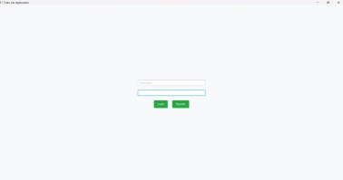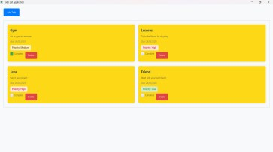

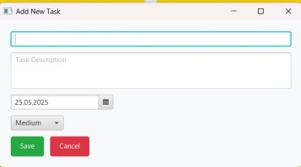

# Architecture

The project follows the MVC pattern.

* Model: Task.java, TaskFileHandler.java
* View: login.fxml, main.fxml, addTask.fxml, main.css
* Controller: LoginController.java, MainController.java, AddTaskController.java

# File Structure todo/

├── src/

│ ├── java/

│ │ ├── controllers/

│ │ ├── models/

│ │ └── utils/

│ └── resources/

│ ├── views/

│ └── styles/

├── tasks/

└── pom.xml

# Feature Summary Table

|  |  |  |
| --- | --- | --- |
| Feature | Implemented | Source Code Files |
| Basic functionality | Yes | Task.java, MainController.java |
| Authentication | Yes | LoginController.java |
| File processing | Yes | TaskFileHandler.java |
| Dark Mode Theme | Yes | Main.css, ThemeManager.java |
| Form Validation | Yes | AddTaskController.java |

# Declaration

I declare that this project is my own work and has not been submitted in any form for another assignment. I have acknowledged all sources used in this report.